**St. Thomas’ College of Engineering and Technology**

Industrial Training report on

**“Android- Movie Search Application”**

Department of Information Technology

7th Sem , 4th Year

Group No. – 03

Group Member Roll No.

Abhirup Das 10

Sabarna Choudhury 09

Shreya Das 11

**INDEX**

* About Project
* Technologies Involved
* Methodolgy
* System Design
* Screenshots of Application
* Conclusion

**About the Project :**

The project aim is to make an application which would search for related information of Movies that are given as an input by the user. On providing the input in the search bar, the related movie list, the respective posters and the plot of the movie will be displayed adjacent to each other in a list by the Application.

On further click, the Application would display the plot in the detailed description, the ratings and the cast, too.

This would provide us knowledge about the movie and its ratings, what the movie is all about.

This android application is to be realized on Android Software Development Kit using OMDb API and TMDB API to obtain the necessary movie information, all content and images. Since access to OMDb API and TMDB API is limited per user, an API key is obtained to keep allowing access to the OMDb API.

**TECHNOLOGIES INVOLVED:**

* Android Sdk(Android 9 API 29)
* Java Programming language
* XML
* OMDB API
* TMDB API

Android Studio and SDK tools has been used to develop the concerned application. OMDb or Open Movie Database is an openly maintained Database of movies and related content contributed by the users. The OMDb API allows accessing data from this database for use in the project.

The programming language in use is JAVA.

**METHODOLOGY**

**Design** - Since User experience depends on the user interface, it needs to be simple yet accomodate all requirements. The app needs to be linked with an API to the OMDb to acquire the list of movies and their details. The user can scroll down to view the entire list of movies.

**Development** - The development of this project involves- setting up the user interface, fetching data using JSON objects from a movie database using API and displaying the required information on the app for the end user.

**Stabilization** - The API fetches data only a limited number of times per user. An API key has to be acquired to keep gaining access to the OMDb and TMDB

**Deployment** - The deployment essentially deals with the implementation of the project in the large scale factor that deals with the generalised outcome of its implementation on any android phones.

As a matter of fact, the scalability itself is so huge that it can be implemented everywhere,ranging from Lollipop, Kitkat and so on.

**SYSTEM DESIGN:**

The application starts with the search page which is initially empty.

Next, as the user inputs a movie name in the SearchView, the API request are sent to the OMDB API, using the API key, which returns the result in form of a JSON Object.

This JSON object is now converted to an Array which is then taken and the required elements like

‘Title’ is extracted.

Further, the Movie poster in the form of BitMap is extracted and decoded for each element which occurs in the result of ‘Search’ array.

For the Description of the movie, the short ‘Plot’ is extracted by using the omdbID from the Search Array and sending another API request.

These are populated on the layout, which in turn is connected by the Adapter to the data.

The RecyclerView in the application to recycle the views that are out of visibility of the user.

The OnBind() method helps in binding the data with the recyclerview , and then inflate It to the user.

The results are connected to the XML layout that has been created and hence produces the output.

**SCREENSHOTS OF APP**

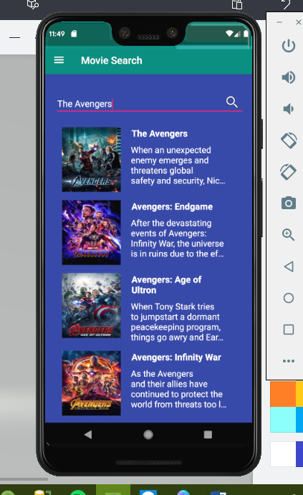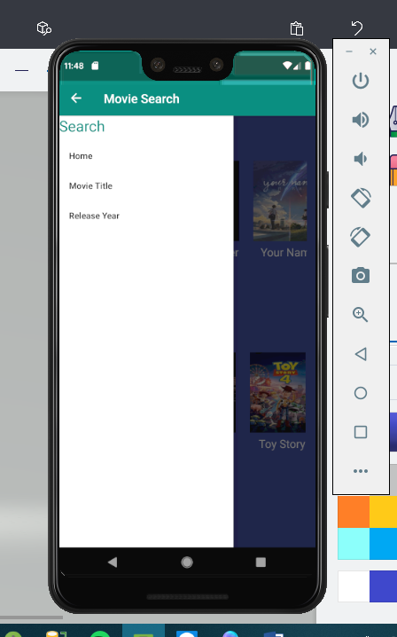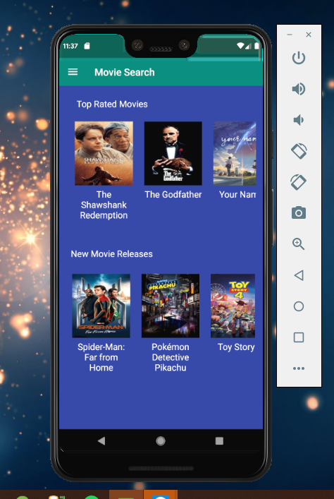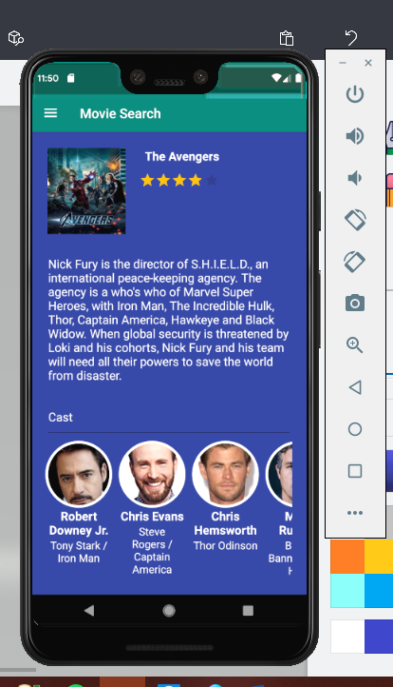

**CONCLUSION**

Several goals were accomplished while working on this team project. First of all an application was created which supports a user’s day planning with the following implemented functionalities:

* Generate a day plan, which is heavily optimized on completing as many tasks as possible.
* Simple, yet powerful task management system
* Continous checking of the dayplan’s consistency and compliance.

The task management functionality of this app is also strongly encapsulated and can therefore be reused easily in any Java project. The storage mechanism of converting tasks into events and storing them at a specific date can also be adapted easily to an Realm database or any other preferred storage solution.